Table of Contents

Pre-Bill Summary ………………………………………………………………………………………………………. 3

Pre-Bill: Submit and Pay for Your Players ………………………………………………………………………. 4

Direct Registration for Inter-Recreational and TOPSoccer Players ………………………………………11

How to Upgrade a Recreational Player to Competitive ……………………………………………………. 12

How to Add and Submit a Transfer Player ……………………………………………………………………. 15

How to Add and Submit Players to the FYSA Tournament Roster Event …………………………… . 18

How to Add and Submit Coaches and Team Managers …………………………………………………… 21

Pre-Purchase a Credit for Membership Billing ………………………………………………………………. 22

How to Pay an Invoice as a Club ………………………………………………………………………………… 24

Pre-Bill Summary

Pre-bill is used for the following player membership purchases:

- All Competitive players
- Recreational players that participate in a league (inter-recreational) that requires a roster and/or passes and/or match cards.

Direct Registration is used for in-house players only. If, during the season, you wish to add a player who was initially submitted to FYSA via Direct Registration to a competitive team or facilitate the club pass feature, please contact jcannon@fysa.com for more information.

Please note the following important points:

- If you wish to purchase per team, please process payment BEFORE submitting any other teams. Each time a team is “submitted,” it will be added to the total amount due at check-out.
- FYSA does not charge for a pass for Coaching Staff or Team Managers; therefore, you will see a balance due of $0.00. You will be required to “submit payment” to access a pass.
- Pre-bill will impact all players requiring a pass (competitive and inter-recreational: players participating in a league against teams from another club).
- In-house recreational and TOPS players will continue to be submitted via Direct Registration, payable in arrears.
  - FYSA will continue to send monthly reminders that payment is due.
    - The club will process payment.
    - You may process payment before the due date.

There are several advantages at the club level that make this a positive change, including:
- You (the club) will have more control over when a player pass is purchased through FYSA for the seasonal year.
- This will give your admin and registrar multiple opportunities to review all registrations before making a payment to assist with accuracy (i.e., reduce accidental registration charges)
- Roster Builder will now display a summary of all player requirements (age verification, photo, FYSA registration, etc.) to make finalizing rosters easier from start to finish.
- Players can be added to a team and not charged for their FYSA seasonal registration until you (the club) are ready.

Which memberships will be purchased via the pre-bill pathway?
All players on competitive and inter-recreational teams (any player who will need a player pass to participate) will be pre-bill.

What will NOT be pre-bill?
In-house/ intra-recreational teams and players will stay direct registration and will be invoiced every 30 days.
Membership fees for the upcoming season will be as follows:

- Competitive Players $26.00
- Recreational Players $13.00
- Upgrade from Rec. -> Comp $13.00
- Coach/Team Manager Pass $ 0.00
- Background Check $40.00

Questions? Email jcannon@fysa.com or submit a support ticket.
Pre-Bill: Submit and Pay for your Players.
Pre-billing is used for all Competitive and Recreational Teams that require a pass. Background checks, in-house Recreational, and TOPSoccer Players will continue to be due on the 1st of each month, and payment will be processed then. FYSA will continue to send monthly reminders. Please note that the club will process the payment administratively.

- Adding players to league/tournament events or the FYSA Tournament Roster pathway will not incur an additional charge.
- Inhouse Recreational and TOPSoccer players will continue to be submitted to FYSA via Direct Registration.
- There is no charge for a pass for Coaches or Team Managers.
- Payment for background checks will become due on the 1st of the month. FYSA will email a reminder.
- Passes/rosters will only be available once players have been successfully registered and paid for. Although there is no fee for Coaches or Team Manager passes, payment of $0.00 must be submitted to print a pass.

To submit and pay for your players:

- Log in to your GotSport account.

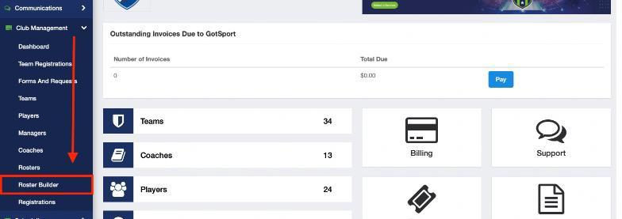
- Click on Club Management -> Roster Builder.

- Select the 2024–2025 FYSA Registration Event from the event drop-down -> click submit.
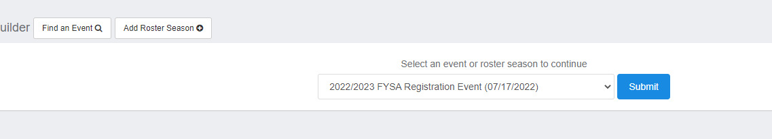
-

- You can now commence adding your Players to teams.
  - The first list of names on the left will represent players that can be added to teams. The teams affiliated with the Registration Event will show on the right.

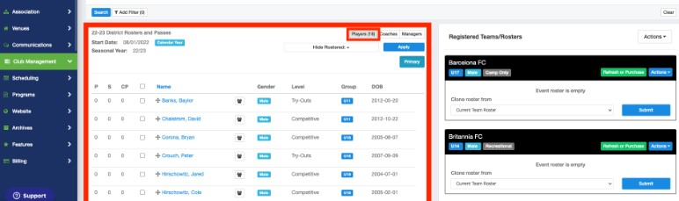

- To add your Players to the roster, either click ‘submit’, which will clone the players from the selected roster (current team is the pool under club management -> teams). Alternatively, you can select the players you wish to add to the team by placing a checkmark in the box to the left of their name (you may use filters at the top of the page to isolate the required players). Then click ADD TO TEAM, located above and to the right of the team’s name.
  - Players and staff can now be added to the roster without all their individual requirements. However, even if payment has been submitted, the pass will be unavailable until all requirements are fulfilled.

Players will now be added to the team. Continue until you are ready to purchase a membership (which will enable you to access passes and the roster).

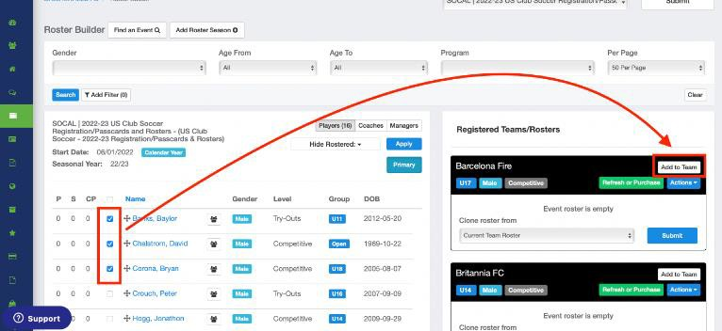

You will see a series of icons next to the players. If this is the first time the player has been added to the team, they will only see the YELLOW YIELD SIGN and RED DOLLAR SIGN.

- The YELLOW YIELD symbol next to a player indicates that the requirements for that user have not been checked. NOTE: This does not mean the requirements (roster rules) are not fulfilled. This indicates that they have not been reviewed yet. They will be checked in the next step.
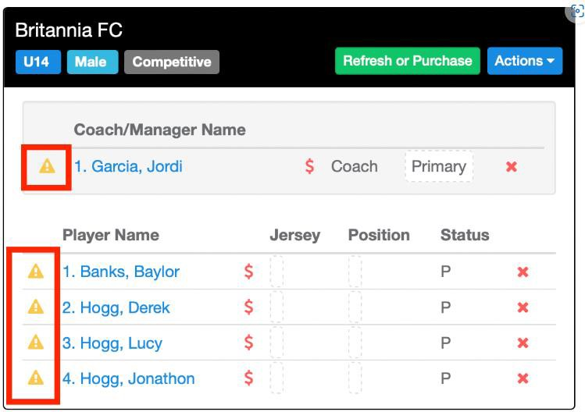

- The GREEN CHECK BOX symbol next to a player indicates that the requirements HAVE been checked and are completed.

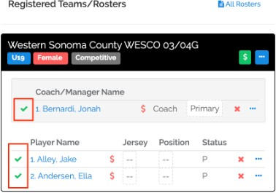

- The RED DOLLAR SIGN symbol next to a player indicates that that user has not been paid for yet.
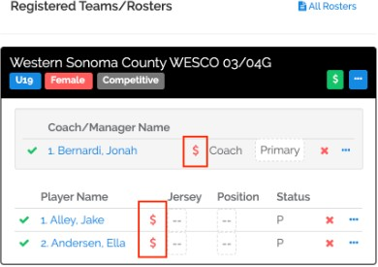

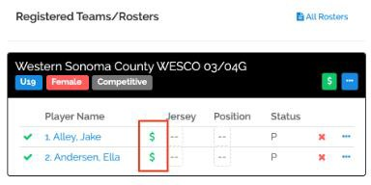
- The GREEN DOLLAR SIGN symbol next to a player indicates that that user has been paid for.

- The orange dollar sign indicates that a player who was initially paid for as a recreational membership has now been added to a competitive team. Therefore, the upgrade fee of $13.00 must be processed before the pass is available.

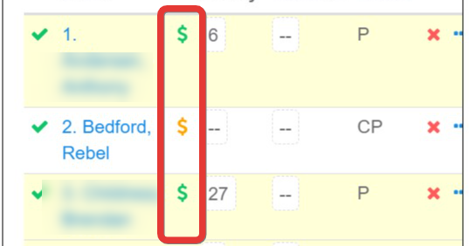

- Once ready to purchase the memberships for a particular team, click on the REFRESH OR PURCHASE BUTTON next to that team's name.
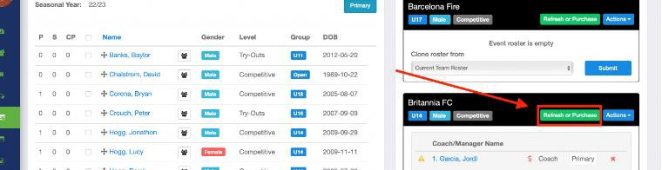

- The system will now check all requirements (roster rules). Any users missing a requirement will have a red error message next to their name. You can still purchase a membership for all users listed. However, the player card will not be available for any user who still needs a requirement. Once the missing roster requirements have been fulfilled, click Refresh or Purchase to link them.
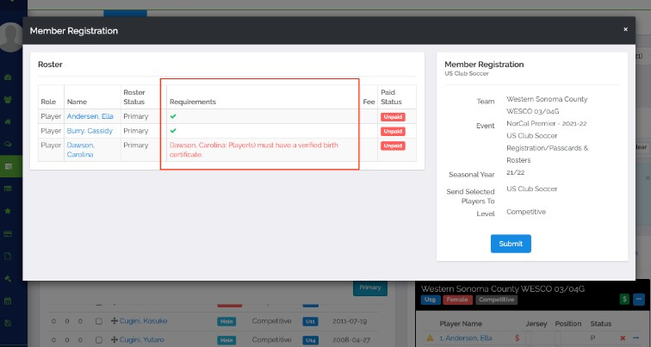

- If you want to continue purchasing the memberships, click the SUBMIT button. Please remember that each time you SUBMIT A TEAM, THE MEMBERSHIP FEES FOR THAT TEAM WILL BE ADDED TO THE OVERALL PAYMENT DUE. If you wish to avoid a large one-time payment, do not submit any further teams until the current balance has been paid. This will not impact on your ability to add players to their teams within the Roster Builder.

(We cannot process any refunds for players inadvertently registered.).
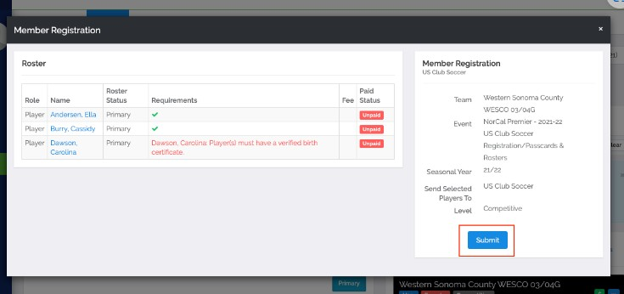

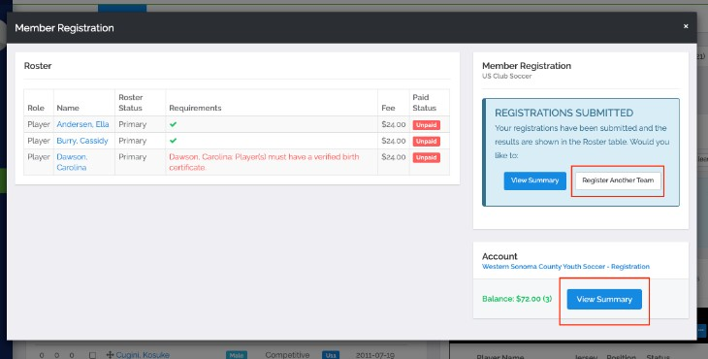
- The staff and players have now been added to your cart. You can now proceed to payment for those users by clicking on VIEW SUMMARY, or you can add more players to your cart by clicking on REGISTER ANOTHER TEAM and repeating from STEP 5.

- You will now be in your cart. Click on PAY NOW and enter your credit card on the pop-up to complete payment. Once done, you will receive confirmation of your payment, and your memberships are now successfully purchased. If you do not wish to pay for your in-house recreational players or background checks until the due date, select the Pay Now option located next to the Competitive Membership fees.
  - You can access the landing page anytime via club management -> registrations.
  - Click “Pay Now,” which will open a window confirming the amount that will be processed. Click on this amount.
  - Enter the credit card to which you wish to process payment (the amount is also confirmed on this page). Once the card information has been entered, click “pay.”

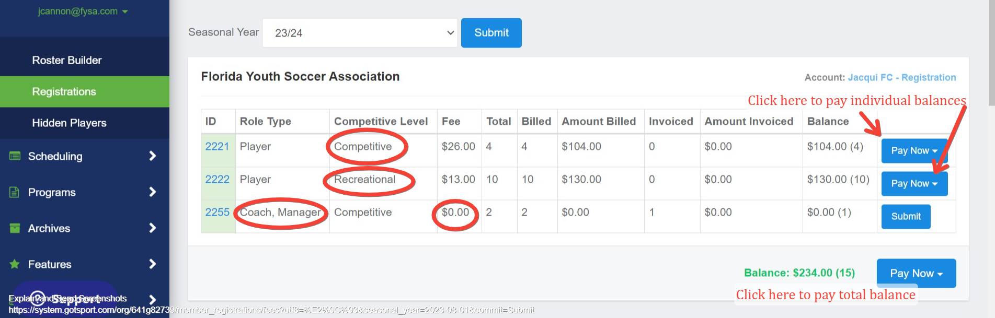

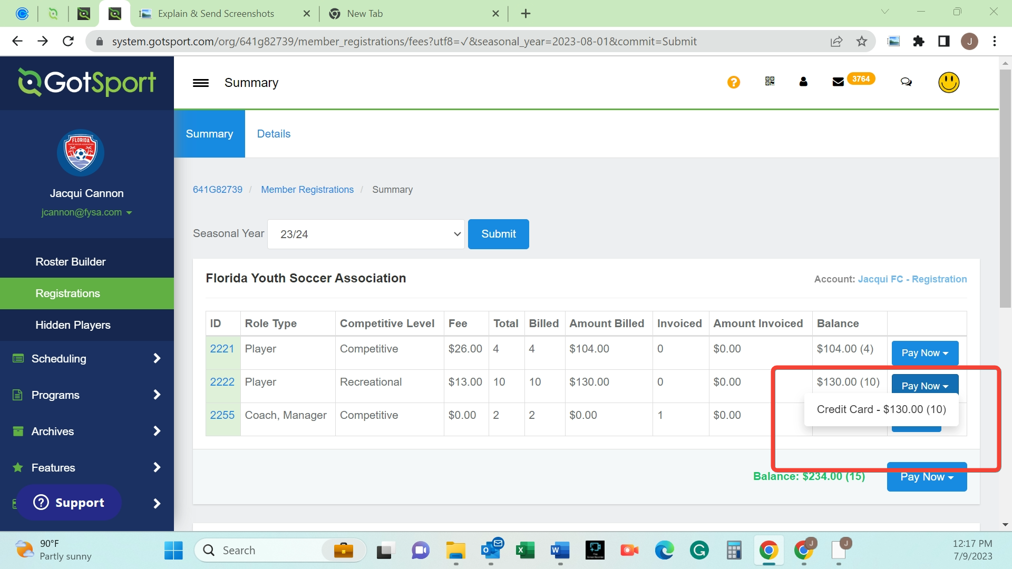

Note: You only have the option to remove memberships from your cart that have yet to be PAID FOR.
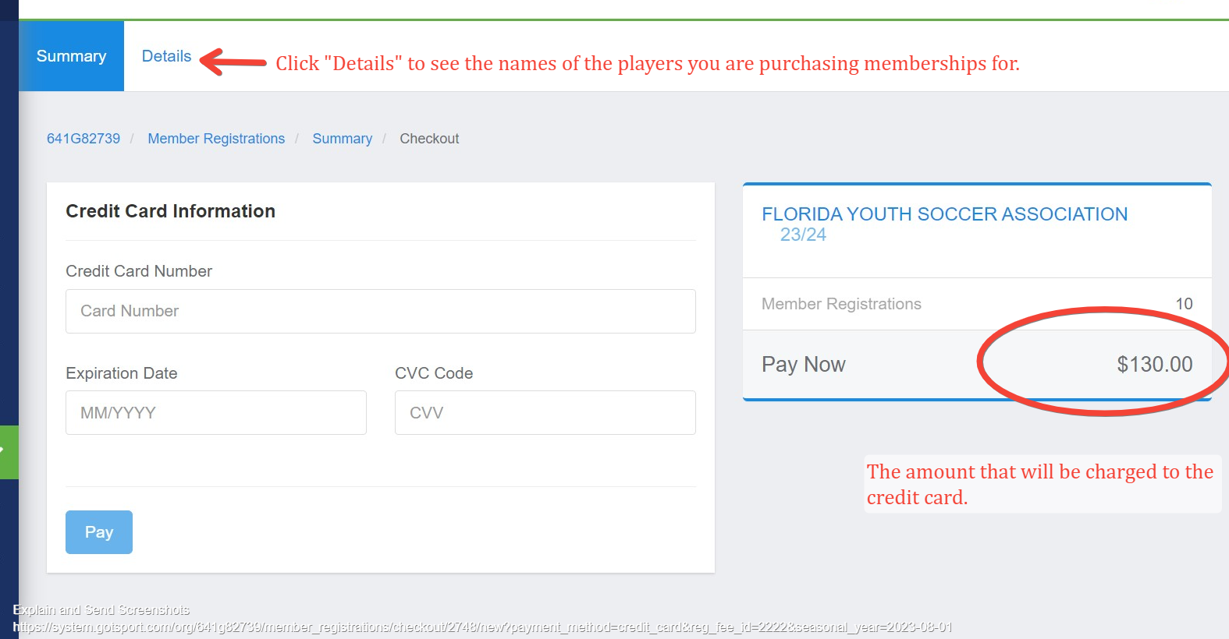

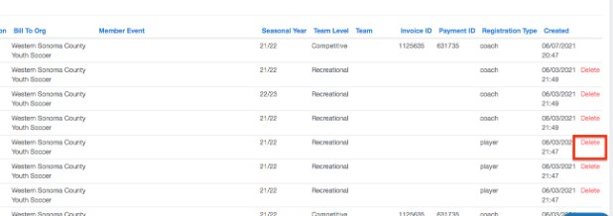

Click SUMMARY at the top of the page to return to your cart. Make sure to choose the correct seasonal year in the drop-down menu.
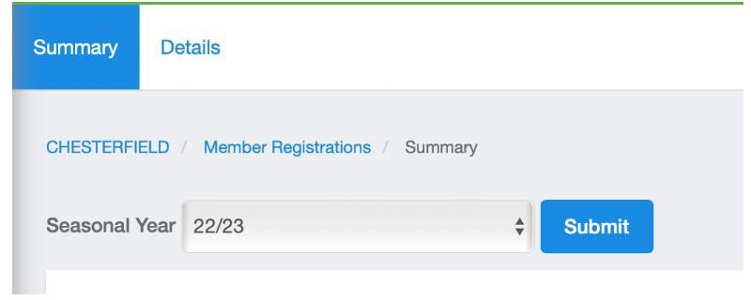

10. Return to step 10 and complete payment. You have now successfully purchased your memberships.

DIRECT REGISTRATION FOR INTER-RECREATIONAL PLAYERS/TOPSOCCER

All recreational/TOPSoccer players that do not require a pass will have their memberships with FYSA created by Direct Registration (this may be upgraded to a competitive level at any point during the season and will be outlined later in this guide).

The data must be submitted accurately, as this will create your billing. It is recommended that you use the filter option to ensure that you capture the correct players to submit to FYSA. We are unable to process any refunds for players submitted in error once payment has been processed.

- Click on Club management -> players -> utilize the filters to isolate the players you wish to submit to FYSA. Select the checkboxes next to the players you want to submit or select the box at the top to the left of ‘Name.’ You will then have the option to choose all the players listed by clicking on the option at the top of the page. This will also confirm the number of players being submitted to FYSA. Please ensure this number is correct, as this will determine the number of players invoiced.
- Once you click “Register,” a new box will open. Select:
  - Florida Youth Soccer Association for the organization to submit players to
  - The correct seasonal year
  - Select the correct level (either Recreational or TOPS).
  - Click “Register” to submit the players to FYSA.
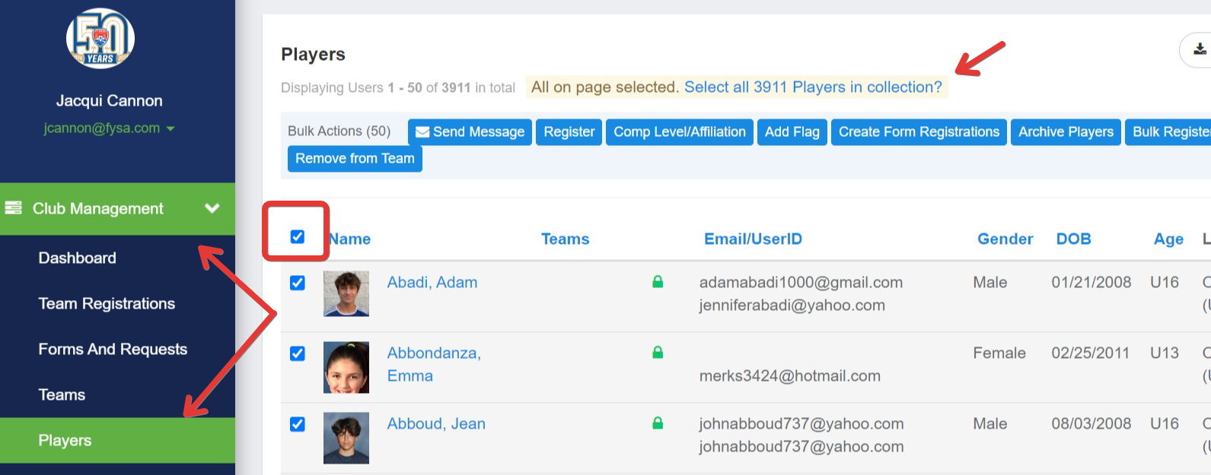

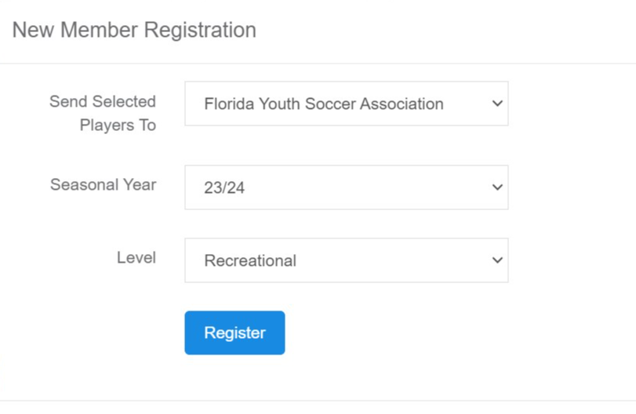

- Next, you will be directed to the summary page once the players have been successfully submitted. You may process payment now or wait until the reminder has been received from FYSA.

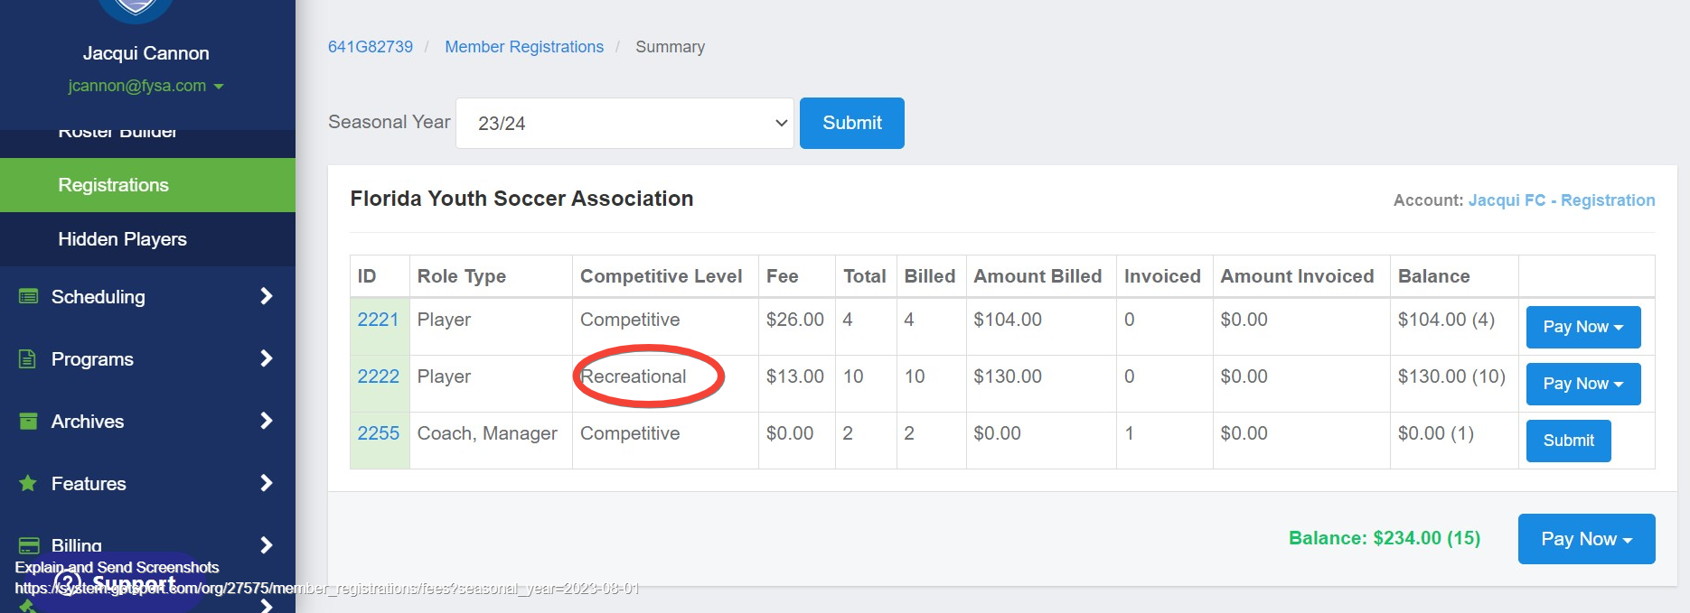

2023-2024
As of July 1, 2023

How to upgrade a Recreational Player to Competitive.

During the seasonal year, upgrading a player from a recreational to a competitive level may be necessary to be rostered to a competitive team.

- Navigate to the roster builder and use the appropriate filters to locate the player and team to which you wish to roster them.
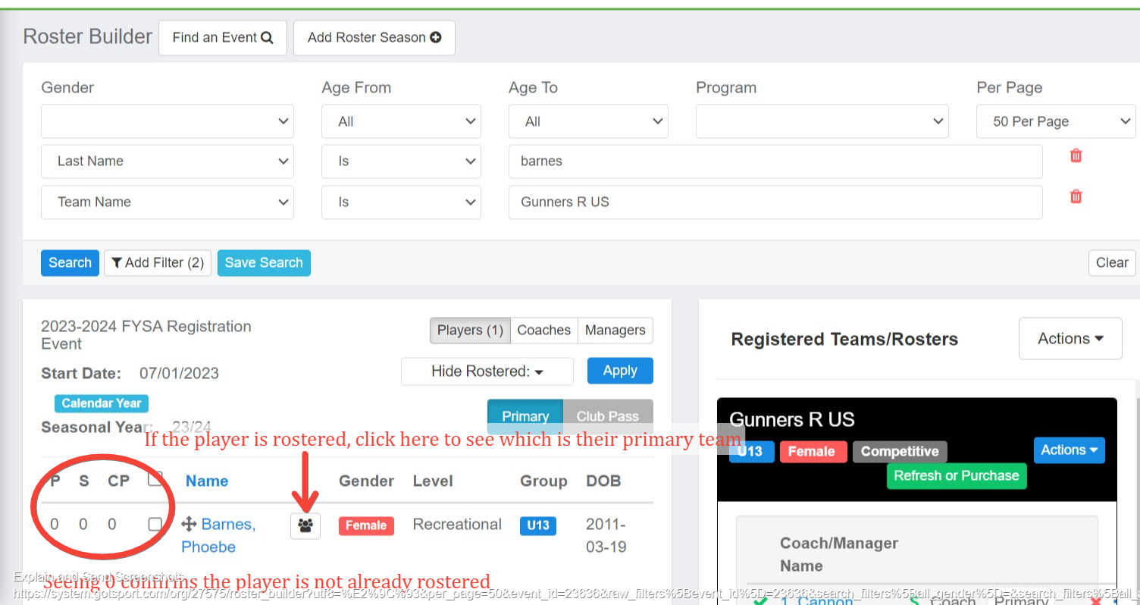

- Click on the toggle to drag/drop the player onto the team – there is no need to adjust the competitive level, as the software will complete this for you based on the level of the team. Enter the jersey number and click Add Player.

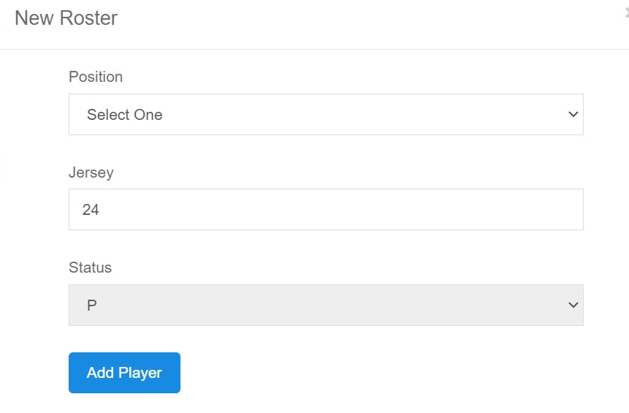

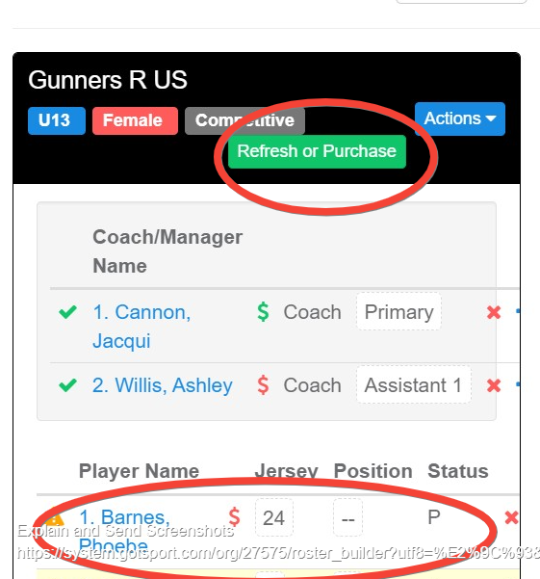

- The player is added to the roster, after which, if you wish to purchase the pass, click Refresh or Purchase -> Submit -> View Summary.

This will direct you to the Summary, showing that the player has been added as an Upgrade with a fee of $13.00 ($13.00 recreational fee + $13.00 upgrade fee = $26.00 competitive fee).

The recreational and upgrade fees must be paid to access a pass. A competitive level and a fee of $13.00 will always indicate that a player has been initially registered at a recreational level and subsequently added to a competitive team.
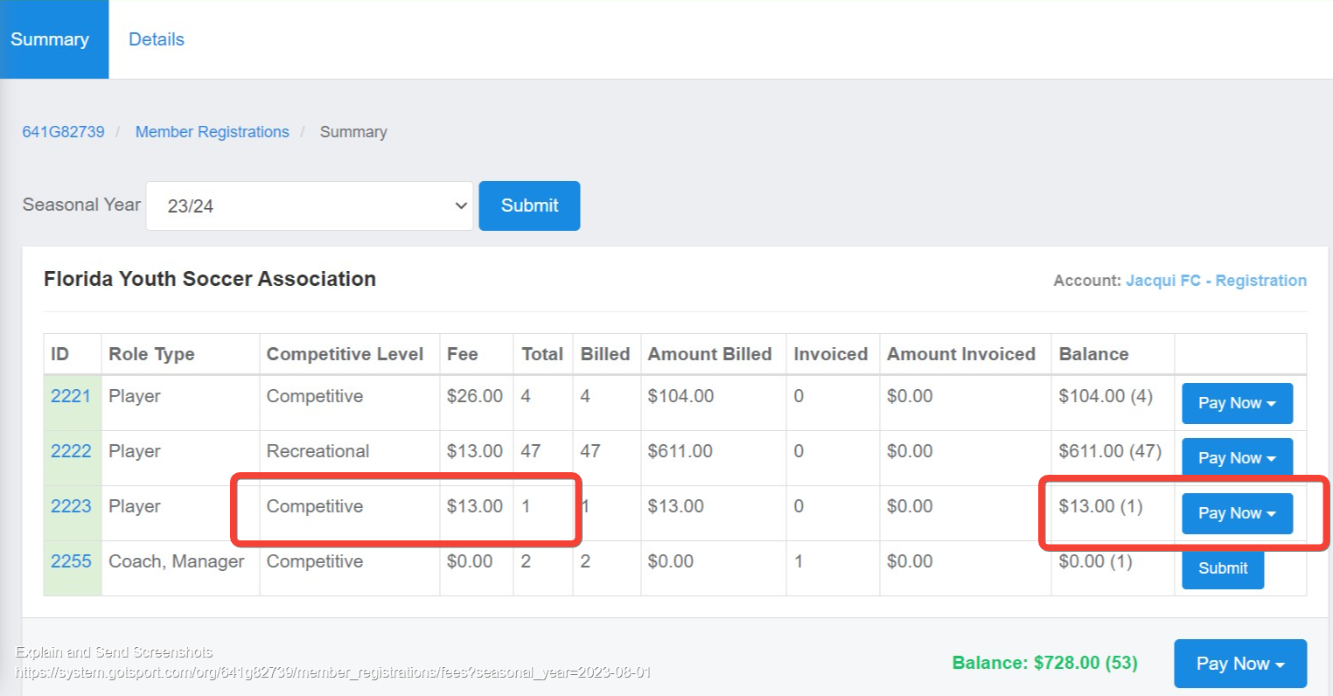

How to Add and Submit a Transfer Player

These instructions will show you how to register a new player coming over to your club and add them to
a roster after they already have an initial registration attached to them.

- Log into your GotSport account.
- Add the player to your club account via Club Management -> Player-> Add new Player.
- Here, you will look up that player and add them to your account (to link immediately, date of birth, first name, last name, email userID, and zipcode -> click select).

Select the correct level from the Comp Level to drop down -> add a user.

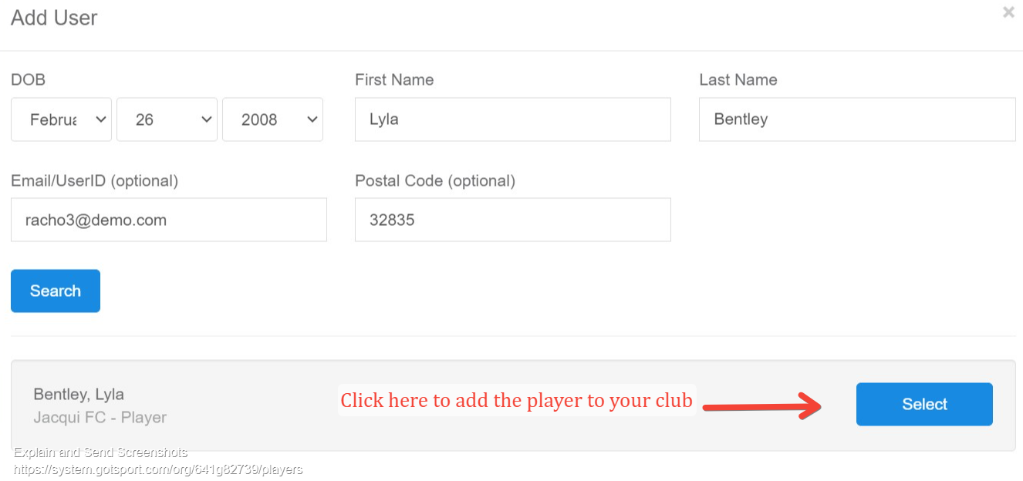

From the Comp Level dropdown box, select FYSA Competitive -> click to add a user.

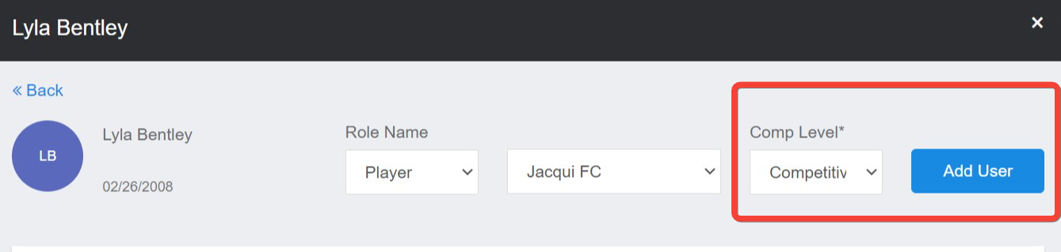

If adding the player only using their date of birth, first name, and last name, an email requesting that the role be approved will be sent to the userID email address. The link expires 24 hours after which it must be resent. Until completed, you cannot locate the players’ information within the Roster Builder. The player's status will remain as ‘Pending’ until the parent or guardian has accepted the role request.

Note:
The ‘Pending’ status does not indicate the players’ previous club is required to complete any administrative release.

- Once in your club account, go to Club Management, select Roster Builder, select FYSA Registration Event, and then click Submit.
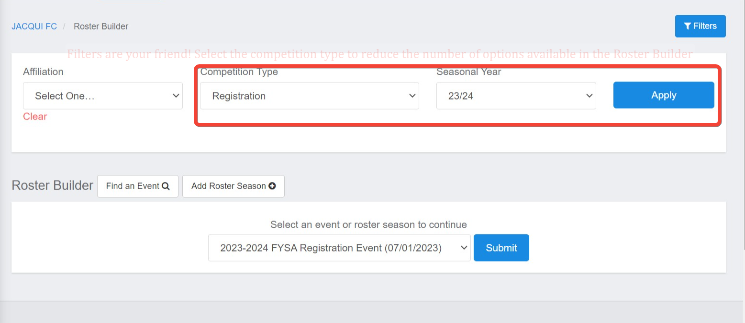

- Add the player to the roster as previously outlined. You will now see the player listed on the team roster with a green check and a red dollar sign next to the player’s name.

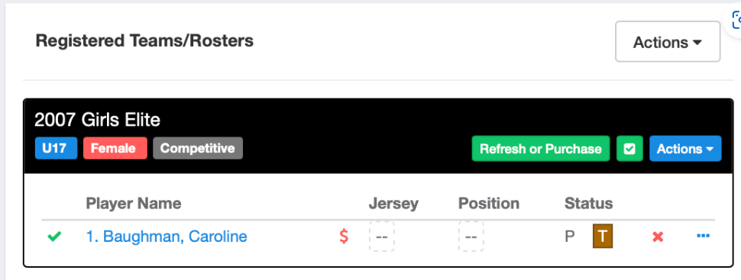

Click the green Refresh button, then click Submit on the next pop-up.
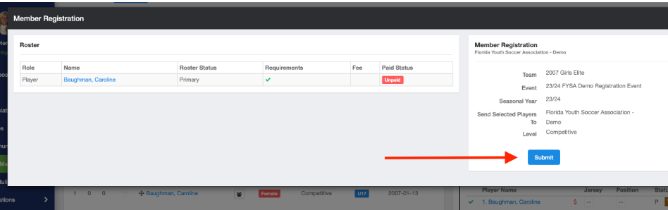

The player has now been submitted to FYSA. The fee is $0.00 as this is the players’ second registration during the seasonal year.
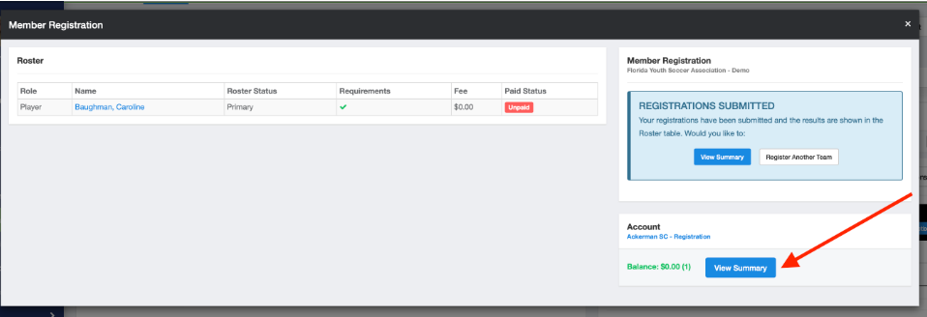
- Click View Summary next to the player of your players’ registrations.

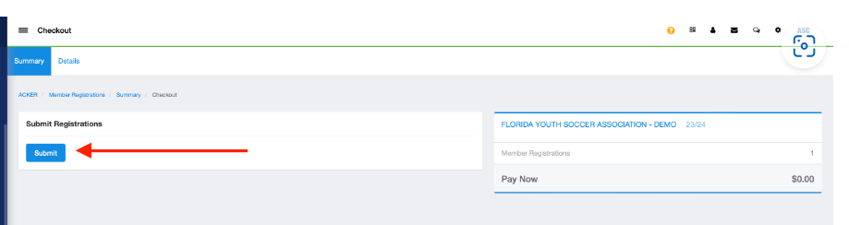
- Click Submit one final time to show a check-out summary for the player(s) you paid for.

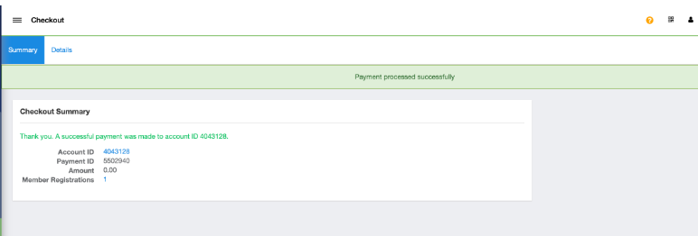

- When you return to the roster builder, a green dollar sign will be next to the players’ name, indicating they have been paid for and making the pass available.

How to Add/Submit Players to the Fysa tournament Roster event.

NOTE: Teams and Players must be initially submitted via the FYSA Registration Event.

The instructions below demonstrate how to submit your teams to the FYSA Tournament Rosters event. This will enable you to build an event roster that will not impact your FYSA Registration Event or League Event documents. Therefore, a correct event roster can be created by adding/removing players (including guests from a loaning club), which is then coned to the specific tournament (this results in the match card being printed correctly, in addition to providing a correct pdf of passes to present for check-in).

PLAYERS MUST BE ROSTERED TO A TEAM WITHIN THE FYSA REGISTRATION EVENT, AND HAVE A MEMBERSHIP PURCHASED, BEFORE PROCEEDING.

- Register the team to the FYSA Tournament Roster Event. From the Dashboard, click CLUB MANAGEMENT, then select TEAMS from the left-hand menu. Register your team to the FYSA Tournament Event (Registration Tab -> Click All Events -> enter FYSA Tournament -> click Search). There is no fee for this service.
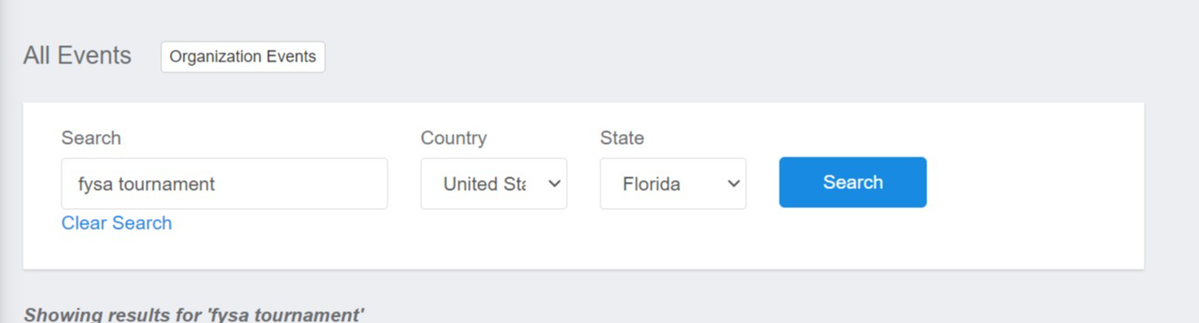

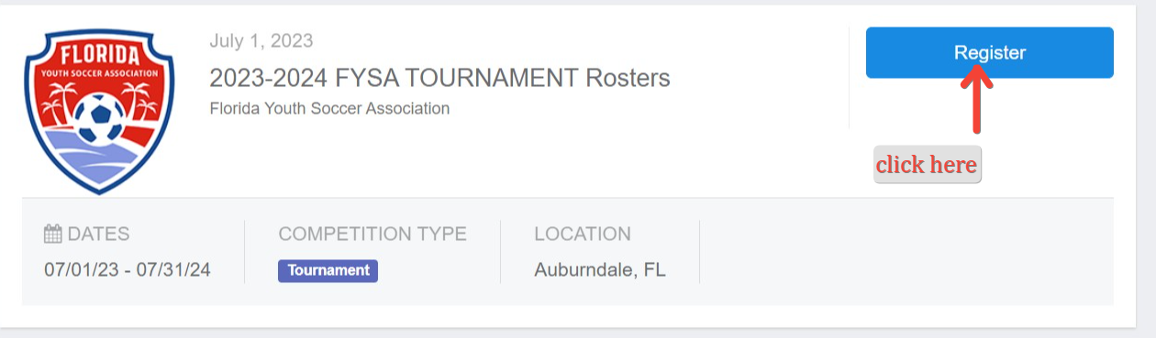

- Via the Roster Builder, navigate to the event.
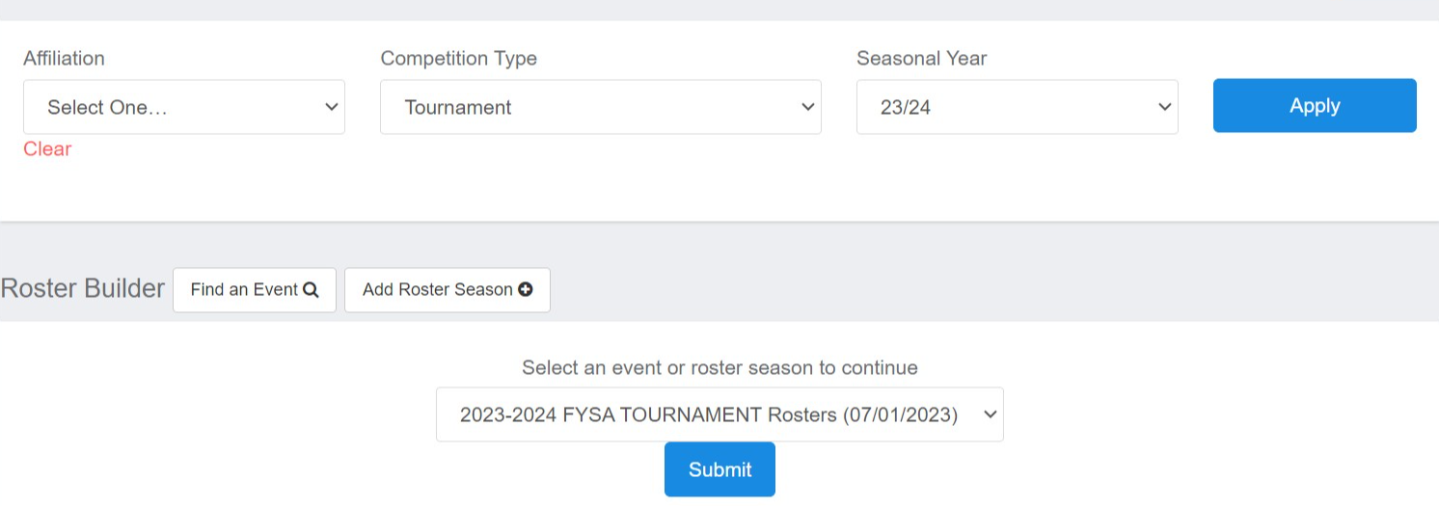

- There are two ways to add your players to the tournament roster:

Select the Clone Roster From your FYSA Registration Event and CLICK SUBMIT (shown in red in the photo below). Removing a player from this roster will not impact the Registration Event/League events. You can also add players already linked in the Registration Event to a different team in the tournament event without receiving an error message (for example, if creating a select tournament team).

OR

Manually select the Players from the list on the left and select Add to Team. BEFORE you add a player, you must first select Primary (Blue), Club Pass (Orange), and Guest (Light Blue), then either check off the player and click Add to Team: or Drag and Drop the player onto the correct team. (Shown in blue in the photo below).

Player status options:
- Primary Players (P) are those registered to your club and primary to this team
- Club Pass Players (CP) are approved Primary players to your club, which you're using to play with another team within your club.
- Secondary Players (S) are players from outside of your own club that are also rostered to your team for the season. NOTE: Secondary/ Dual Rostering will only refer to Players playing in 2 different clubs.
- Guest Players (G) are players from outside your club who are guests playing for your club in a particular event. IMPORTANT: The outside-of-the-club guest player can only be added if the proper electronic Guest Form has been executed and approved by both clubs

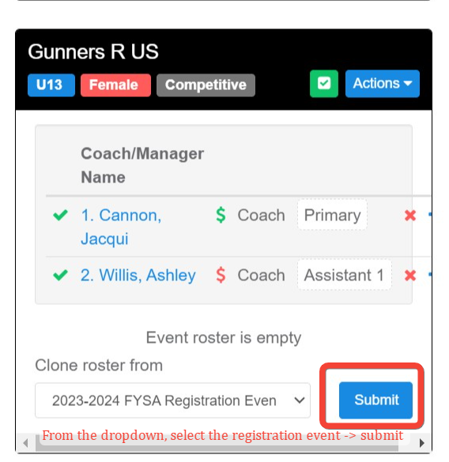

Players who have met roster eligibility and purchased their membership will show a green check mark against their name. Click the green Check Mark to refresh the team; those with a green check mark/green dollar sign will have their passes available with a $0.00 fee.
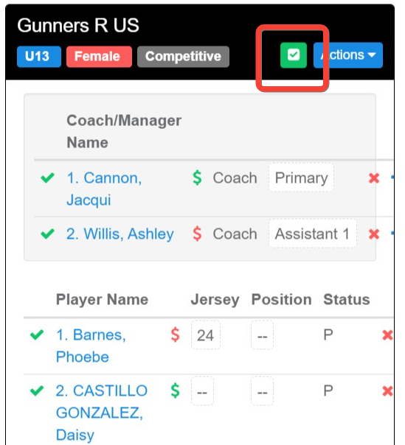

- To access the passes, click on Actions and select ID:
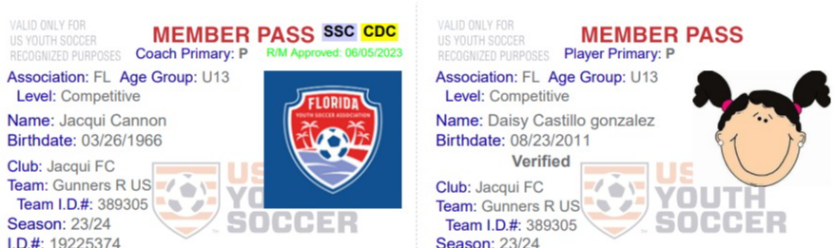

Accessing Passes for Coaches and Team Managers.

FYSA does not charge a membership fee for coaches and team managers. To access their pass, they must be added to the Registration Event and have fulfilled all risk management requirements. The steps below will outline how to access their pass.

- Once the coach has been added to the roster and meets all risk management requirements, click Refresh or Purchase. Then click Submit, followed by View Summary.
- From the Summary page, click Submit on the Coach/Manager line:
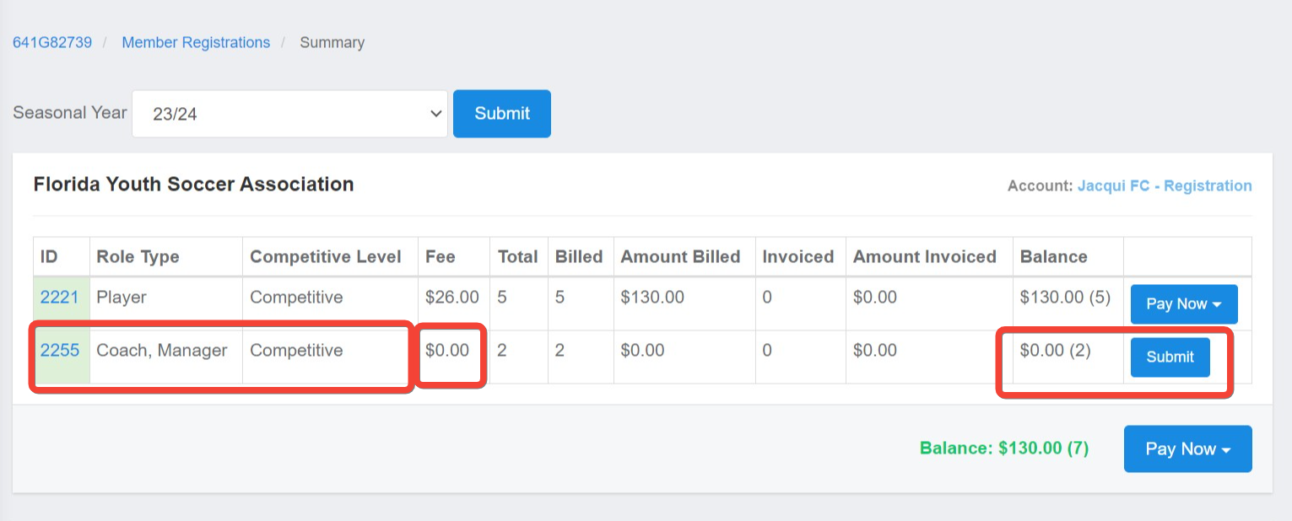

Click Submit a second time.
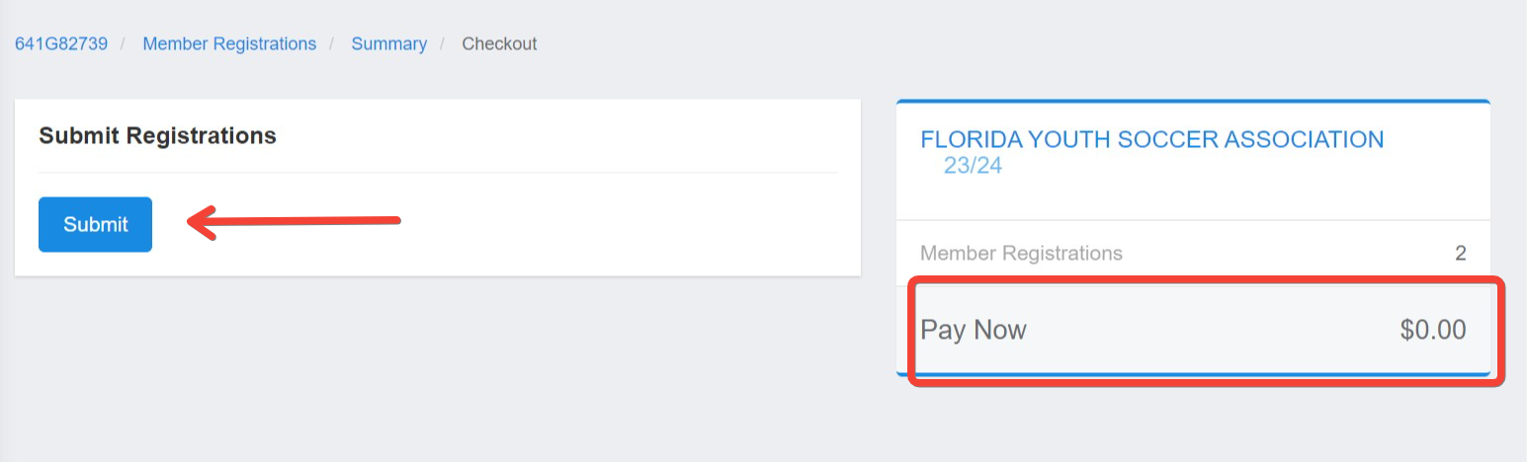

Once finalized, the pass will be available.

Pre-Purchase a Credit For Membership Billing.

1. Log in to your account (How to Login)
2. Click on the Registration Billing account on your dashboard
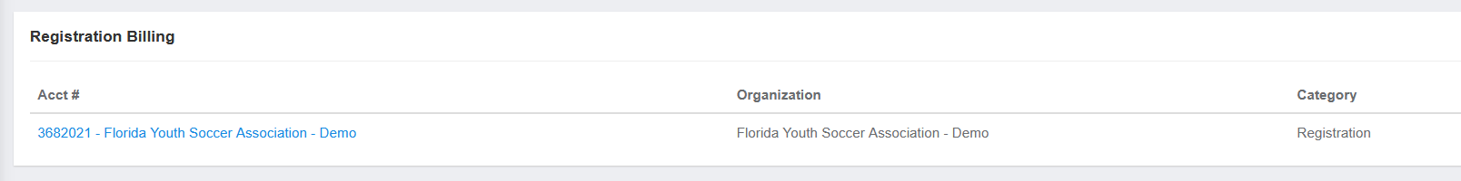

- Click on the Change Payment method.

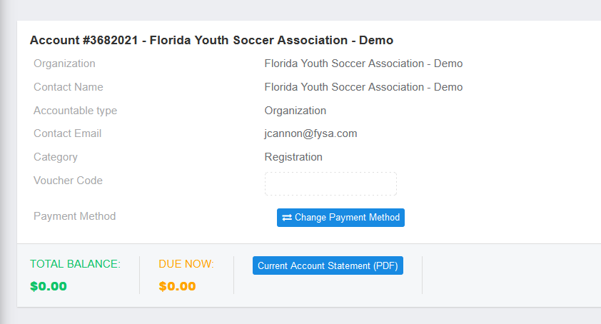

- Enter your credit card details and click Change Payment Method.

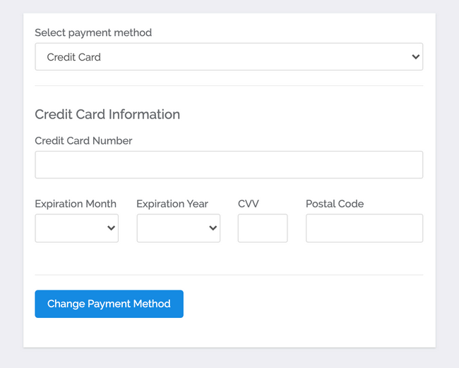
5. Click on New Payment.
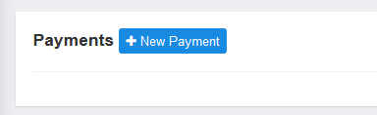

6. Enter the amount of credit you would like to purchase and click PAY
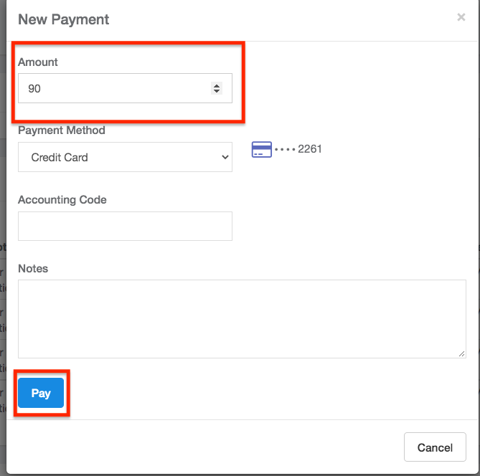
7. You will now have a negative balance on file representing your purchased credits. Any player registration from your club will automatically draw from this amount when paying for player registration. You will be prompted to pay by credit card when the balance runs low.
NOTE: You must enter the amount covering the entire balance of the players you want to register at that time. If your credit is lower than the amount owed, the amount you currently have on your credit will not be deducted from the amount owed.
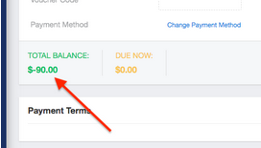

8. Go to Club Management - Registrations and click Pay Now to pay your Balance. If you have enough credit, you will choose the Account Credit option to draw the money from your pre-paid credit.
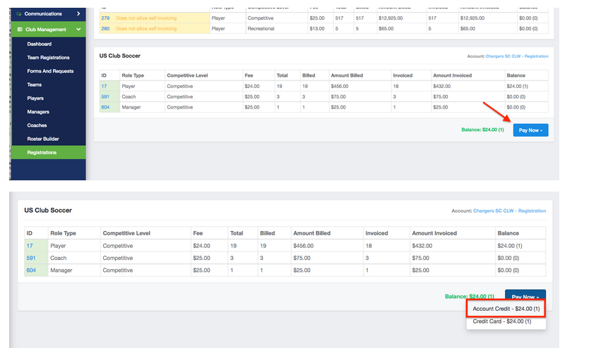

How to Pay an Invoice as a Club.

This article will show you how to Pay an Invoice as a club that has been created for Recreational Players (Direct Registration) and background checks.
- From the Dashboard, scroll to the bottom and click on the account # and name. (This is the fastest option).
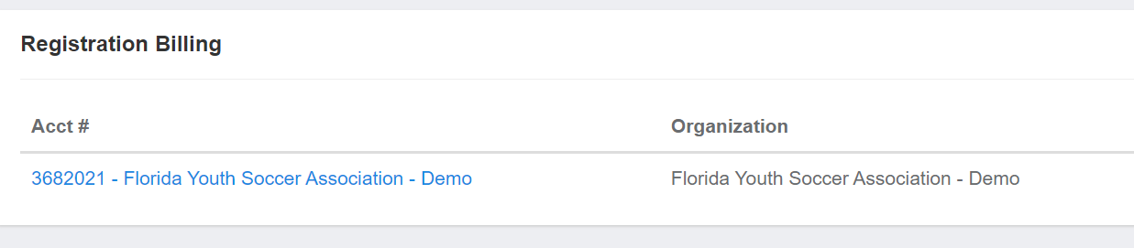

- Once here, you will select Change Payment Method close to the top of the page.
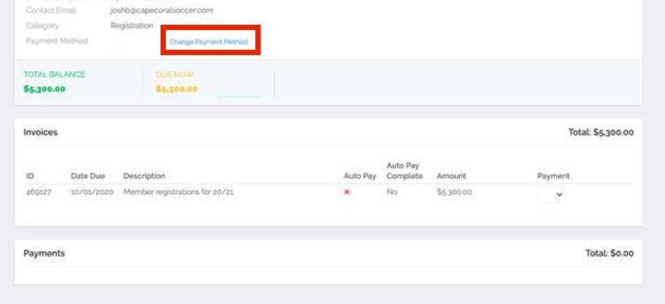

- On the landing page, you will enter your card information and select Change Payment Information

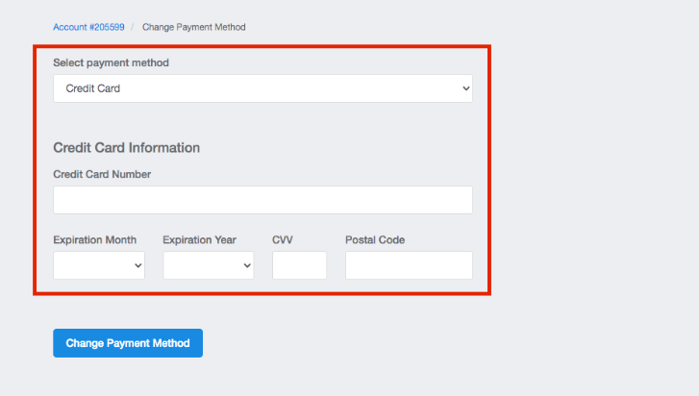

- Once the card has been entered, you will be brought back to your billing page and see that the card is on file. Click Pay Now to process payment.

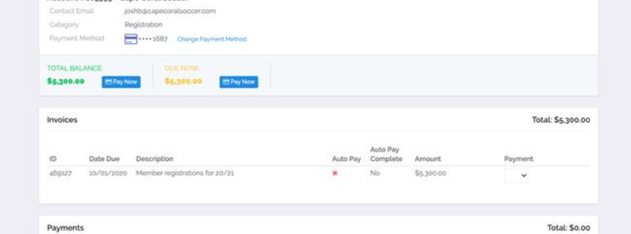

Questions? Email jcannon@fysa.com or submit a support ticket to FYSA.

